# FMX Mobile Application Development

**Lab Exercise 02.01: Starting up with InterBase**

Open the InterBase Server Manager (choose **Start > Programs > Embarcadero InterBase 2017 > InterBase Server Manager [instance = gds_db]**).

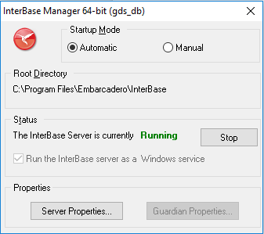

Use **Start** to start the server. The status text changes to **Running**.

To see additional information about the InterBase Server, select **Server Properties**.

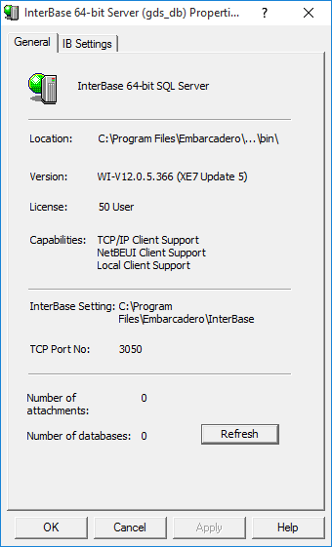

To see additional information about the InterBase Guardian, select **Guardian Properties**.

To log on to the local InterBase server:

1. Open IBConsole.
2. Use **Server > Login**.

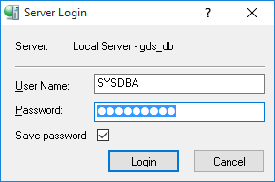

1. Login using the default credentials (user:SYSDBA, password:masterkey).
2. You can see the name of the logged-in user in the status bar of IBConsole